**DIGITAL SIGNAL PROCESSING LAB**

**Lab sheet. No : 03**

**NAME: NIKHIL KILARI Roll.No: EE16B017**

**Question 1**

**Aim:**

To find the convolution of two discrete time signals

X[k] = k+1 if 0<=k<=4, 0 otherwise and h[k] = 1-k if 0<=k<=3, 0 otherwise.

**Short Theory:**

1. Find the convolution of x[k] and h[k]
2. Find the convolution of x[k] and h[k-2]

**Key Commands:**

* zeros()
* conv()
* circshift()

**Result:**

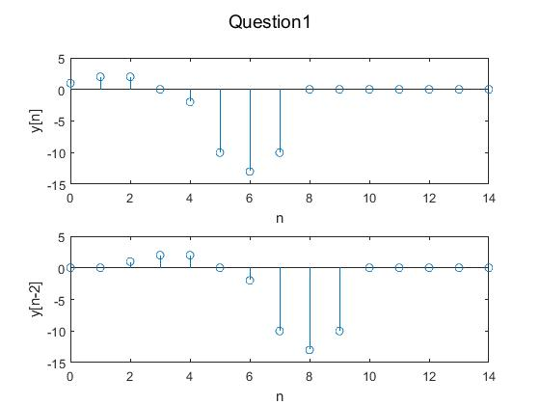

**Inferences/comments:**

* Convolution of x[n] and h[n-2] is the time delayed version of x[n] and h[n] since the system is time invariant.

**Question2**

**Aim:**

To find the even and odd part of the signals

1. x1[n] = [5 4 6 7 3 2]
2. x2[n] = sin(2πfn)+cos(πfn)

**Short Theory:**

Even part = (x[n] + x[-n])/2

Odd part = (x[n] - x[-n])/2

**Key Commands:**

* fliplr() – flip the signal left to right
* stem()

**Result:**

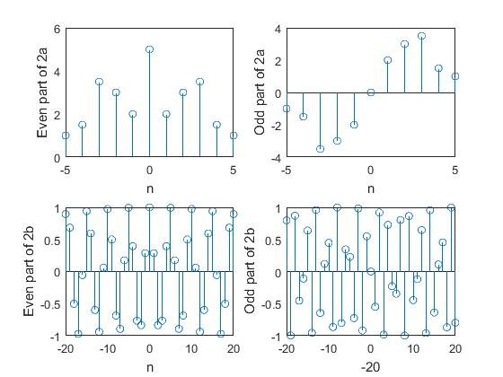

**Inferences/comments:**

* The even part is symmetric while the odd part is asymmetric.

**Question3**

**Aim:**

To use

x1[n] = u[n] – u[n-10] and x2[n] = n for 0<=k<=10 and 0 elsewhere

and check whether the following systems are linear and/or time invariant.

1. y1[n] = x[n-3] * x[n-2]
2. y2[n] = x[n+2]
3. y3[n] = sin(x[n])

**Key Commands:**

* zeros()
* circshift()

**Result:**

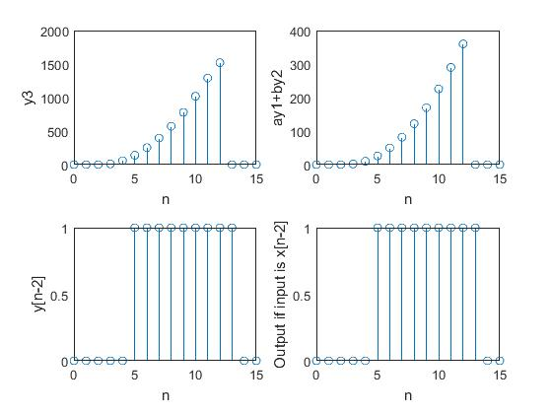

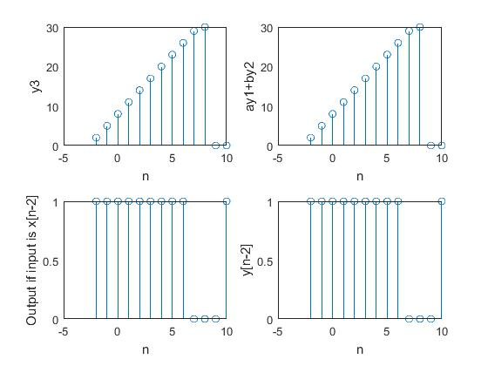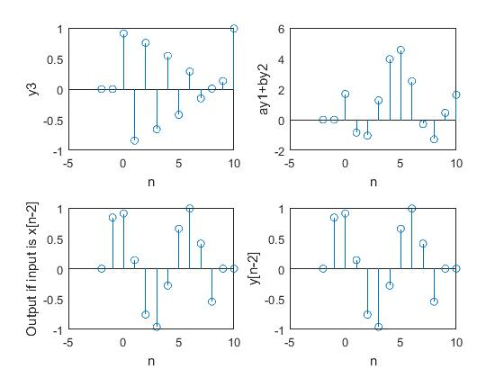

**Inferences/comments:**

* 3a is time invariant
* 3b is linear and time invariant
* 3c is time invariant

**Question4**

**Aim:**

To plot the given impulse responses and state whether the given system is is causal and/or stable.

**Key Commands:**

* sin()
* stem()
* zeros()

**Result:**

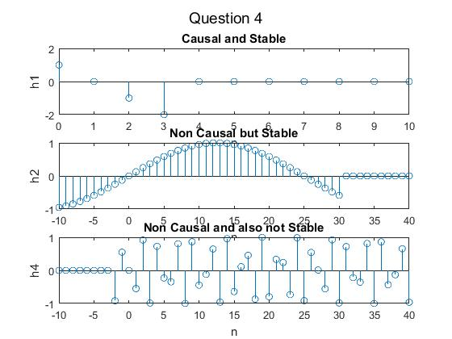

**Inferences/comments:**

* We can infer that a) is causal and stable because for n<0 h[n] = 0 and fir is always stable.
* b) is non causal but stable because for n<0 it has non zeros values and it is again finite impulse response which makes it stable.
* c) is non causal and also not stable.

**Experimental Exercises:**

**Question2**

**Aim:**

To use audioplayer and audiorecorder functions in MATLAB to record and play the audio activity of the surroundings, and then to downsample the signal and reconstruct the signal from the downsampled signal and observe the changes.

**Short Theory:**

Record using audiorecorder play using audioplayer object created. Downsample using downsample() and reconstruct using upsample().

**Inference/Comments:**

* The downsampled signal is pretty fast.
* The reconstructed signal is not as good as that of the original one.